## **What is a Neural Network?**

A neural network is a series of algorithms that endeavors to recognize underlying relationships in a set of data through a process that mimics the way the human brain operates. In this sense, neural networks refer to systems of neurons, either organic or artificial in nature. Neural networks can adapt to changing input; so the network generates the best possible result without needing to redesign the output criteria.

A neural network works similarly to the human brain’s neural network. A “neuron” in a neural network is a mathematical function that collects and classifies information according to a specific architecture. The network bears a strong resemblance to statistical methods such as curve fitting and regression analysis.

A neural network contains layers of interconnected nodes. Each node is a perceptron and is similar to a multiple linear regression. The perceptron feeds the signal produced by a multiple linear regression into an activation function that may be nonlinear.

Neural networks help us cluster and classify. You can think of them as a clustering and classification layer on top of the data you store and manage. They help to group unlabeled data according to similarities among the example inputs, and they classify data when they have a [labeled dataset to train on](https://pathmind.com/wiki/supervised-learning). (Neural networks can also extract features that are fed to other algorithms for clustering and classification; so you can think of deep neural networks as components of larger machine-learning applications involving algorithms for [reinforcement learning](https://pathmind.com/wiki/deep-reinforcement-learning), classification and [regression](https://pathmind.com/wiki/logistic-regression).)

Neural Network Elements :

Deep learning is the name we use for “stacked neural networks”; that is, networks composed of several layers.

Neuron -

The layers are made of *nodes*. A node is just a place where computation happens, loosely patterned on a neuron in the human brain, which fires when it encounters sufficient stimuli. A node combines input from the data with a set of coefficients, or weights, that either amplify or dampen that input, thereby assigning significance to inputs with regard to the task the algorithm is trying to learn; e.g. which input is most helpful is classifying data without error? These input-weight products are summed and then the sum is passed through a node’s so-called activation function, to determine whether and to what extent that signal should progress further through the network to affect the ultimate outcome, say, an act of classification. If the signals passes through, the neuron has been “activated.”

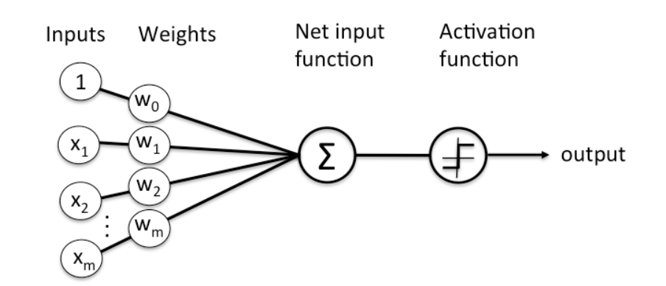

In deep-learning networks, each layer of nodes trains on a distinct set of features based on the previous layer’s output. The further you advance into the neural net, the more complex the features your nodes can recognize, since they aggregate and recombine features from the previous layer.

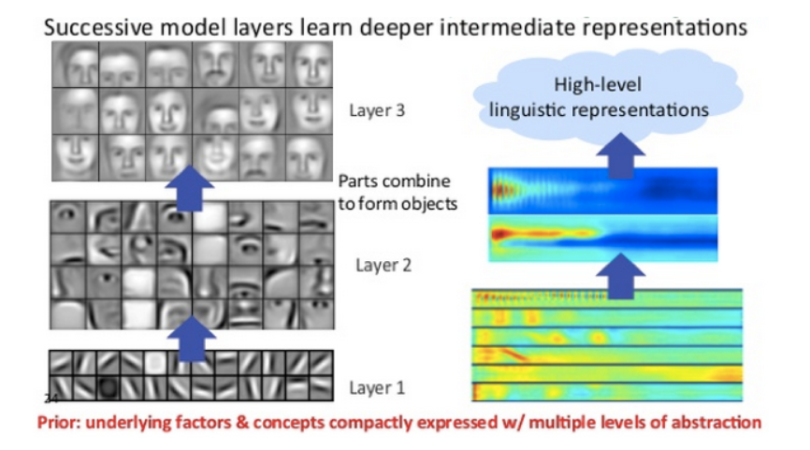

This is known as **feature hierarchy**, and it is a hierarchy of increasing complexity and abstraction. It makes deep-learning networks capable of handling very large, high-dimensional data sets with billions of parameters that pass through [nonlinear functions](https://pathmind.com/wiki/glossary#nonlineartransformfunction).